**Arushi**

**23BCC70014**

**Experiment -1(Full Stack)**

**Student Registration Form with HTML5 Validation**

**Aim:**

To design and implement a basic student registration form using HTML5 that collects user information and performs input validation.

**Theory:**

HTML5 provides several input types and attributes that allow validation directly in the browser without writing JavaScript. This includes:

1. required: Ensures the field must be filled before submission.
2. type="email": Checks that the input is a valid email address.
3. type="number": Accepts only numerical values.
4. min, max: Sets allowed ranges for numbers.
5. pattern: Allows custom regular expression matching.
6. placeholder: Provides user guidance inside input fields.

Using these features improves user experience and ensures data integrity before it reaches the server.

**Procedure:**

1. Create a new HTML file (e.g., student-registration.html).
2. Inside the <body>, add a <form> element with relevant fields.
3. Use HTML5 attributes like required, type, min, and placeholder to validate input.
4. Add a submit button to allow users to send the data.
5. Open the file in a browser and test the form by filling out incorrect and correct values.

**Code:**

<!DOCTYPE html>

<html lang="en">

<head>

<meta charset="UTF-8">

<title>Student Registration Form</title>

<style>

body {

font-family: Arial, sans-serif;

margin: 40px;

background-color: #f2f2f2;

}

form {

background-color: white;

padding: 20px;

border-radius: 8px;

max-width: 400px;

margin: auto;

box-shadow: 0 0 10px rgba(0, 0, 0, 0.1);

}

input, label {

display: block;

margin-top: 10px;

width: 100%;

}

input {

padding: 8px;

margin-top: 5px;

}

button {

margin-top: 15px;

padding: 10px;

background-color: #4CAF50;

border: none;

color: white;

font-size: 16px;

cursor: pointer;

width: 100%;

}

button:hover {

background-color: #45a049;

}

</style>

</head>

<body>

<form>

<h2>Student Registration</h2>

<label for="name">Full Name:</label>

<input type="text" id="name" name="name" required placeholder="Enter your full name">

<label for="email">Email Address:</label>

<input type="email" id="email" name="email" required placeholder="example@email.com">

<label for="age">Age:</label>

<input type="number" id="age" name="age" required min="5" max="100" placeholder="Enter your age">

<button type="submit">Register</button>

</form>

</body>

</html>

**Output:**

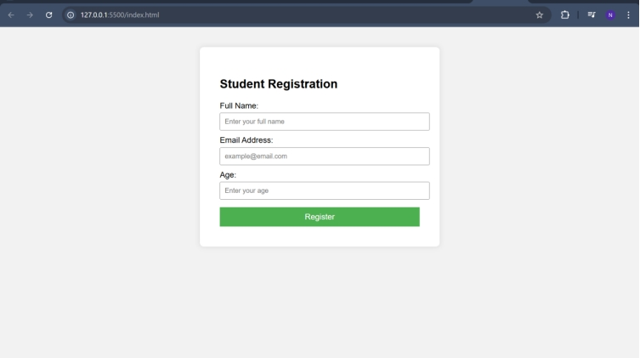

**Learning Outcomes:**

1. By completing this practical, the student will be able to:
2. Understand the importance of form validation in web development.
3. Use HTML5 input types and validation attributes effectively.
4. Design accessible and user-friendly web forms.
5. Validate user data directly in the browser without JavaScript.